|  |
| --- |
| Øvelsesrapport: Sternberg |
| Sebastian Beck  PJG511 |
| 4/12-2019 |

Index

Introduction 3

Method 3

Materials 3

Test procedure 3

Results 4

Searching is a serial exhaustive process that starts by unmasking the probe 4

Accuracy is influenced by set size, masking and probe presence, but not speed 6

Individual experiences may differ 7

Conclusion 8

References 9

# Introduction

Sternberg (1969) aims to investigate how we search for, and retrieve, information from our short term memory. It does this through the scope of stage theory. Stage theory states that the time between a stimulus and response, is occupied by a series of mental operations (Sternberg, 1969). These operations are arranged in such a way, that one process starts once the preceding has ended. The reaction time (RT) is therefore the sum of the duration of all stages (Sternberg, 1969). By assuming pure insertion and using the subtraction method, one can investigate the brain processes by conducting two experiments which only differs in one variable. Sternberg (1969) investigates whether searching functions as a parallel or a serial process and if it is either self-terminating or exhaustive.

Our experiment aims to investigate:

1. Whether searching is a serial or a parallel process.
   1. If serial: Whether it is a self-terminating or exhaustive process.
2. Whether a distorted probe is unmasked before searching starts or if it is done on a continuous basis.
3. Whether we see a speed-accuracy trade-off and if this is affected by probe condition.

# Method

This experiment included *N* = 194 participants, all psychology students at UCPH. Age and sex differences were not considered.

## Materials

* E-Prime® experiment file containing Sternberg experiment
* PC

## Test procedure

Present during the experiment was only the participant (P). Instructions was included in the experiment file. The experiment starts by a fixation cross appearing for 1000ms followed by 1000ms of blank screen. At this point a memory set of 2-5 letters were shown on the screen for a time equal to 500ms per letter, again followed by 1000ms of blank screen. Finally, a probe is shown on the screen, and P decides whether it was present in the memory set. This must be done as quickly and accurately as possible and is done by pressing either 1 (yes) or 2 (no) on the keyboard. The probe can be either masked or unmasked. A masked probe is distorted by having two vertical and two horizontal grey lines behind it. The experiment consists of 12 blocks of 12 trails. The trails are 50% yes and 50% no and are presented in a random order.

# Results



Figure 1: Average RT for all conditions.

## Searching is a serial exhaustive process that starts by unmasking the probe

Figure 1 seems to support the notion that searching is a serial process. This is because the apparent linear relation between RT and size of memory set. To test this, a repeated measures ANOVA test was conducted. It showed significant main effects of set size, F(1.48, 286.14) = 278.39, p < .001, $η_{p}^{2}$ = .59 (Huyhn-Feldt corrected), and test letter (present vs. absent), F(1, 193) = 58.49, p < .001, $η_{p}^{2}$ = .23, but no significant interaction between set size and test letter, F(1.90, 366.60) = 2.05, p = .13, $η_{p}^{2}$ = .01 (Huyhn-Feldt corrected). The main effect of set size supports that searching is a serial process as stated above. The main effect of test letter indicates a difference in RT dependent on the probe being present in the memory set or not. Figure 1 shows that masked probes follows the same pattern as unmasked probes, but with a higher zero-intercept. This indicates that the probe is unmasked in the beginning of the search process, in opposite to comparing the masked probe directly to the memory set.

To test this, a repeated measures ANOVA was used. This showed significant main effects of set size, F(1.38, 265.51) = 462.24, p < .001, $η_{p}^{2}$ = .71 (Huyhn-Feldt corrected), and masking, F(1, 193) = 273.39, p < .001, $η_{p}^{2}$ = .59, but no significant interaction between set size and masking, F(1.84, 354.66) = 0.55, p = .56, $η_{p}^{2}$ = .003 (Huyhn-Feldt corrected). The main effect of set size and masking shows that RT varies due to set size and if the probe is masked or not. The lack of interaction shows that RT is affected equally in each of the conditions. This is furthermore supported by paired samples *t-*test (two-tailed, a = .05) comparing intercepts and slopes in figure 2. This showed a significant difference between the intercepts of graphs for masked and unmasked conditions, *t*(193) = -5.68, *p* < .001, *d* = 0.38, but no significant difference between the slopes of the graphs, *t*(193) = -0.89, *p* = .38, *d* = 0.07.

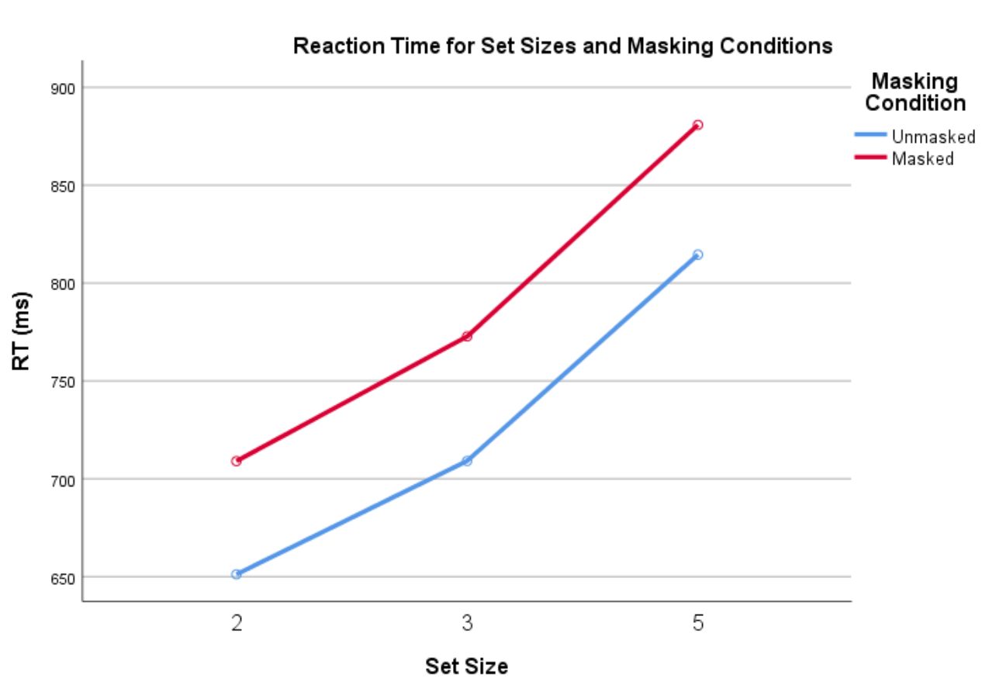

Figure 2: RT as a function of set size.

## Accuracy is influenced by set size, masking and probe presence, but not speed



Figure 3: Accuracy for all conditions and set sizes.

Looking at figure 3, accuracy seem to be affected by many variables: Set size, the masking and the presence of the probe. But each condition seems to be affected differently. To test these, a repeated measures ANOVA was conducted. It showed significant main effects of set size, F(2, 386) = 17.04, p < .001, $η_{p}^{2}$ = .08, of masking, F(1, 193) = 9.25, p = .003, $η_{p}^{2}$ = .05, and of test letter (present vs. absent), F(1, 193) = 118.64, p < .001, $η_{p}^{2}$ = .38. The test furthermore showed significant interactions between set size and masking, F(1.88, 363.26) = 6.64, p = .002, $η_{p}^{2}$ = .03 (Huyhn-Feldt corrected), between masking and test letter, F(1, 193) = 44.80, p < .001, $η_{p}^{2}$ = .19, and between set size, masking, and test letter, F(2, 386) = 7.27, p = .001, $η_{p}^{2}$ = .04, but no significant interaction between set size and test letter, F(2, 386) = 0.05, p = .95, $η_{p}^{2}$ = 0.00. The main effects show that accuracy is affected by all the variables. The interaction between masking and set size shows that accuracy is affected differently dependent on set size and if the probe is masked. The interaction between masking and test letter means that masking effects accuracy differently dependent on probe presence. The three-way interaction means that the overall influence of any two factors, are dependent on the third factor. The lack of interaction between set size and test letter, means that the rank order of accuracy is always the same.

A Pearson’s correlation (two-tailed) was used to test for a speed-accuracy trade-off. This showed no significant correlations between RT-5-Mask-pres and acc-5-mask-pres, *r*(192) = .12, *p* = .09, between RT-5-maskAbs and Acc-5-maskabs, *r*(192) = .08, *p* = .28, between RT-5-unmasked-pres and acc-5-unmasked-pres, *r*(192) = .10, *p* = .18, or between rt-5-unmasked-abs and acc-5-unmasked-absent, *r*(192) = .01, *p* = .95. No correlations means that we didn’t see a speed-accuracy trade-off for memory sets of 5 in our data.

## Individual experiences may differ

Figure 4: Average RT for all conditions (FP19203)

Figure 5: Average accuracy for all conditions (FP19203)

In comparing figure 1 and 4, and figure 3 and 5, we see an example of individual differences. For instance, it is seen in figure 4 that RT for absent trails seem to be the highest, whereas in figure 1 we see that masked trails have the highest RT. In figure 5 we see that accuracy is highest for present trails, in comparison with figure 3 where the highest accuracy is for absent trails. These differences might be due to mnemonic techniques or strategies, such as chunking.

# Conclusion

The experiment has shown that searching is a serial exhaustive process, in which a masked probe is unmasked before searching starts. Furthermore, we haven’t found any speed-accuracy trade-off.

# References

Sternberg, S. (1969). MEMORY-SCANNING: MENTAL PROCESSES REVEALED BY REACTION-TIME EXPERIMENTS1. *American Scientist*, *57*(4), 421–457.